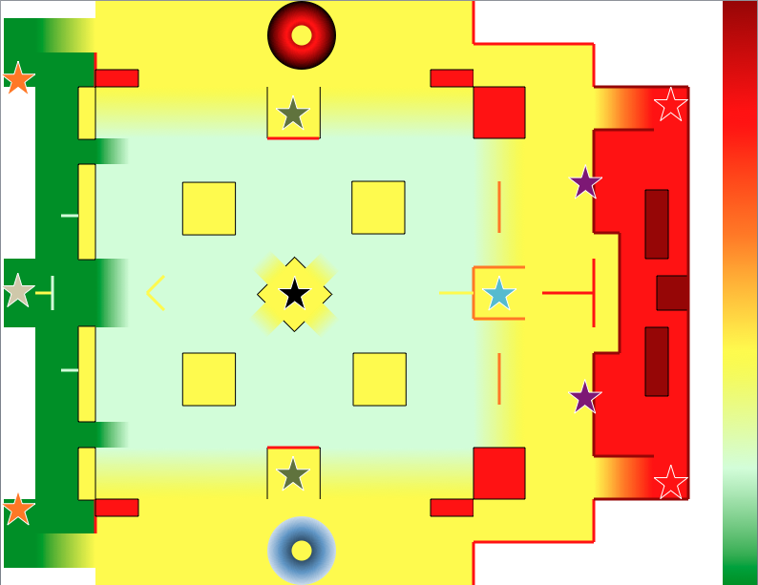

Sniper

Low Altitude to High Altitude: One color difference = Exposed while standing, hidden by crouching

Blue Team Spawn

Red Team Spawn

Sniper

Plasma Rifle

Plasma Rifle

Sticky Grenades

Rocket Launcher

AR

AR

Grenade Launcher

BR

BR